Dear Church Family,
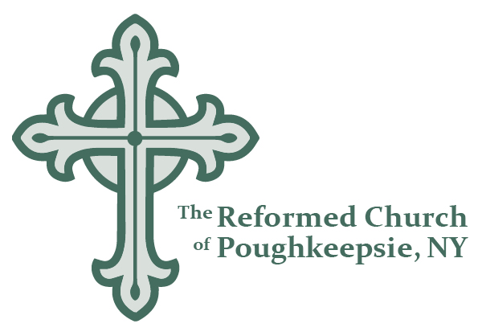

This letter addresses concerns about the spread of Coronavirus and is meant to assure you that the Reformed Church of Poughkeepsie maintains a healthy environment for our congregation. Although the Center for Disease Control is releasing new information every day, it is prudent that we take a few actions that will help us all.

1. Sanitize hands: Each entry into the sanctuary on Sunday will not only have your liturgy bulletin, as is the custom, but will also have hand sanitizer available, which we encourage you to use. Washing hands works, too!

2. Nursery team: Providers will continue to sterilize toys and equipment each week and our Sunday School teachers will remind kids to cover coughs and sneezes and to promptly wash their hands. However, we recognize that there are limits to our prevention measures and parents will have to evaluate for themselves how comfortable they feel about utilizing nursery care during the service.

3. Assess your health and the health of your household: If you or members of your family have flu-like symptoms or a cough, we ask you to stay home and take care of you and yours instead of attending worship. Our parish family tends to be elderly, which is one of the most vulnerable populations. If you are sick, please let Pastor Jason know by calling the church office (845-452-8110) or by emailing (jelder@poughkeepsiereformedchurch.com) so we can check on you.

4. Changes to the Passing of the Peace (greeting time): For the time being we can modify how we greet one another, especially during the passing of the peace. We encourage you to wave, smile, throw a peace sign, or, hey, give an elbow greeting. We can still connect without making contact!

5. Communion and Food Prep Procedures: Communion prep is carried out by members of the consistory, who will be wearing food prep gloves. Those serving or preparing food for coffee hour will also be wearing food prep gloves.

5. Mid-Week Cleaning Method: Kristin Kondysar is our sexton and cleans the building during the week. She is disinfecting door handles, stair rails, and other high touch areas.

Our priority is to continue our connection to each other while being mindful of the current national health issue and heightened anxiety and daily disruption that it breeds. Let's pray together for those who oversee the response to this disease, for those in the medical profession testing and treating patients, and for those afflicted.

Grace and Peace,

Rev. Jason Elder

